1. **Write a java program to print the elements in Array?**

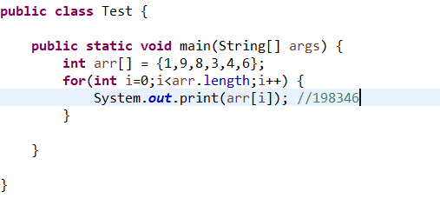

1. **Sort array in ascending order?**

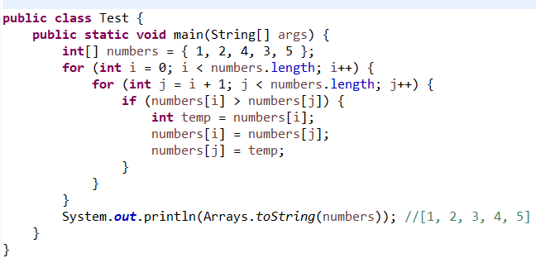

1. **Sort array in descending order?**

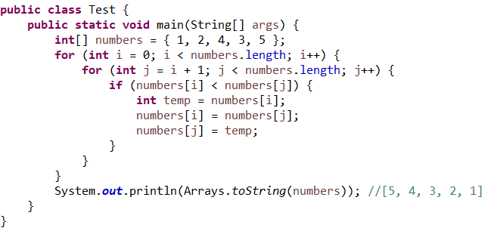

1. **Find Missing Number in Array?**

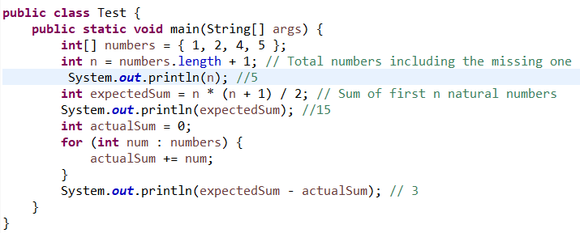

1. **Find First Highest Number in Array?**

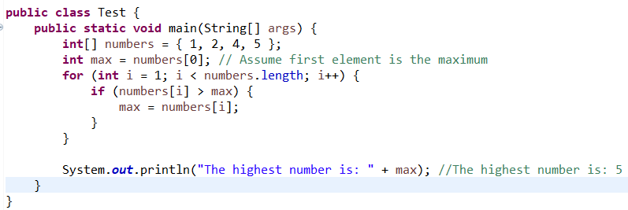

1. Find Second Highest number in array?
2. Find nth highest number in array?